| Test 1 — Outline (Revised 2/1/18) | |
| --- | --- |
| Course Information: Phys 2B | Instructor Name: John R. Walkup |

### Equations Provided

***d*** = ***v***o*t* + (1/2)***a****t*2 ***v*** = ***v***o + ***a****t*  ***F***net = *m****a*** ***F***g = *m***g** *V* = *kQ*1*/r  V* = *Ed R = L/A*

*k =* 9 X 109(SI units) *WC = –*PE *WNC =* E *Wnet =* 😐E *W* = *Fd*cos     😐  *mv*2

*E*Q = *kQ/r*2 PE = *kQ*1*Q*2*/r V = IR C = k*o*A/d C = Q/V e =* 1.6 X 10-19 *C E = hf*

*B =* *oNI/(2**r)* o*=*4 *X 10-7* (SI units) *F* = *qvB*sin *F = BIL*sin

### All questions are multiple choice – be sure to bring a Scantron.

#### Multiple-choice questions

1. This will be one of the conceptual questions from one of your homework assignments. (Review all of the homework problems that did not involve typing a numerical answer.)
2. This will be another one of the conceptual questions from one of your homework assignments.
3. This will be yet another one of the conceptual questions from one of your homework assignments.



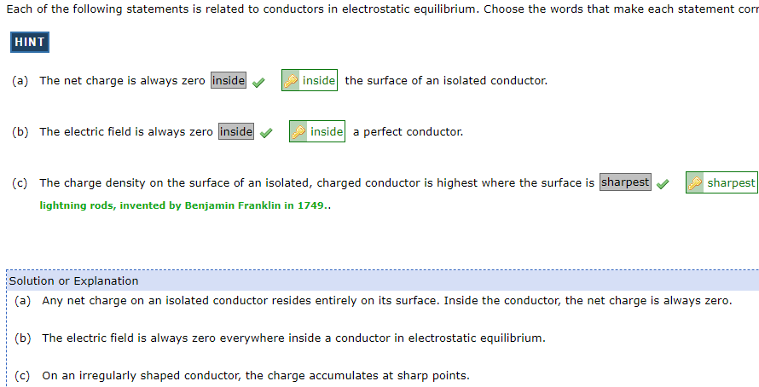

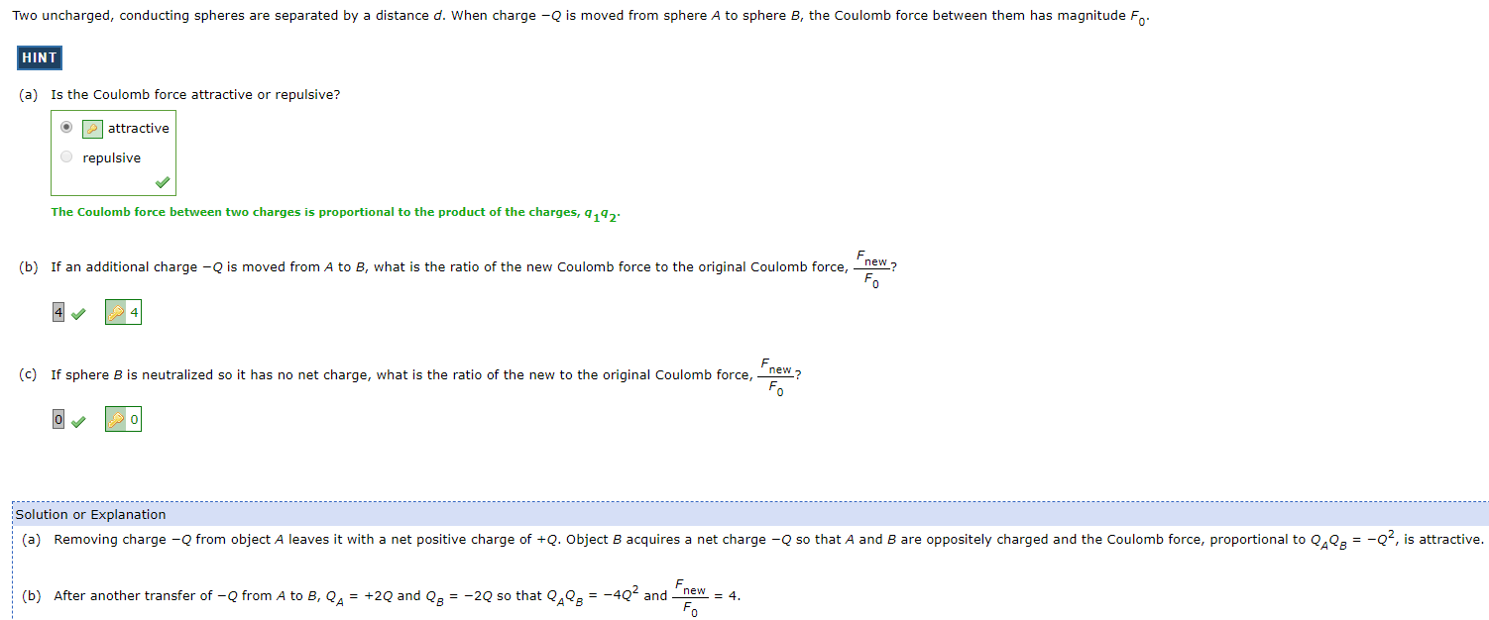



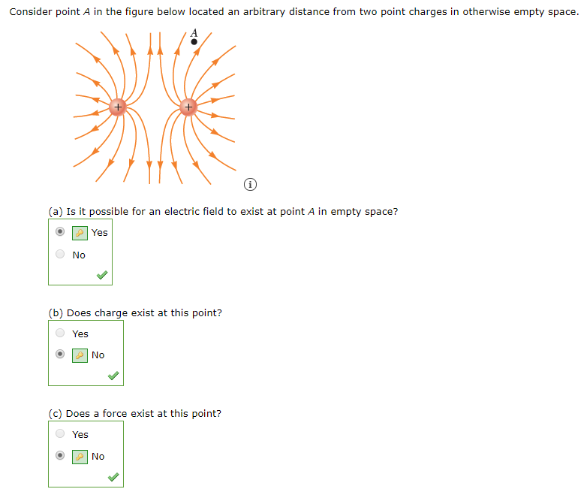

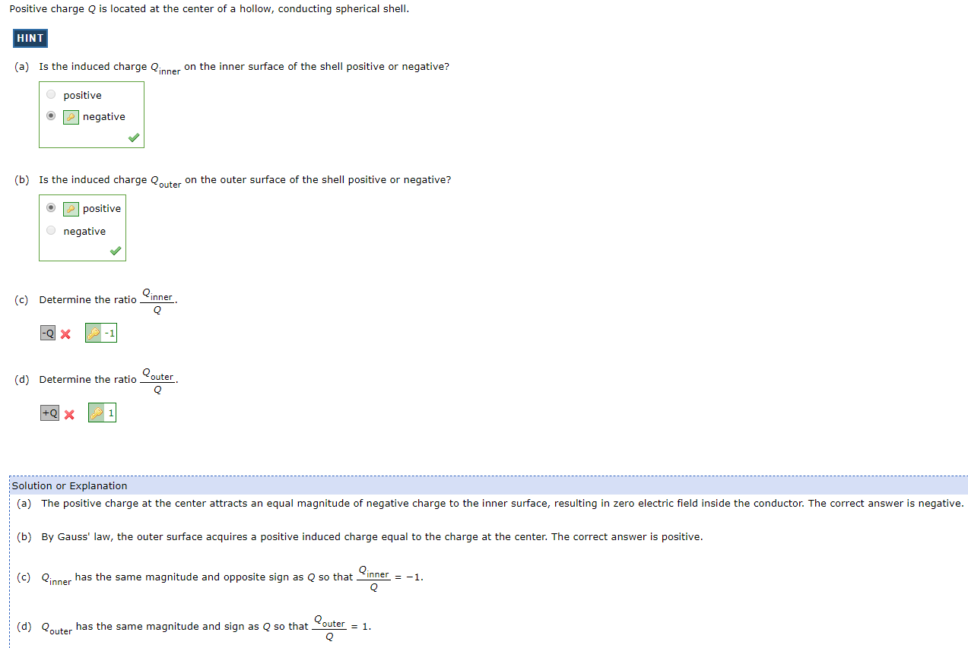

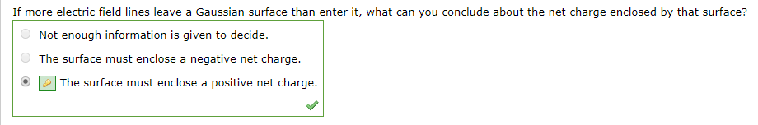



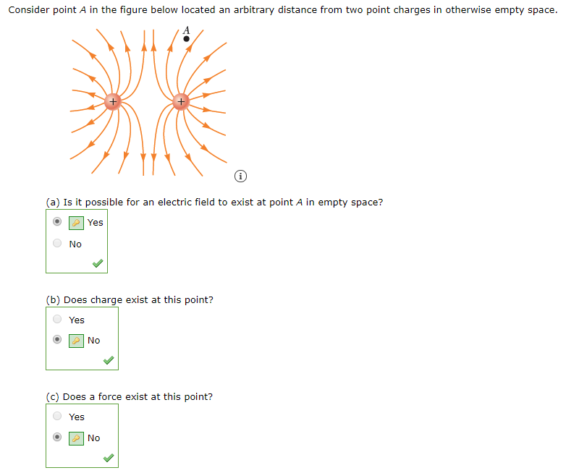

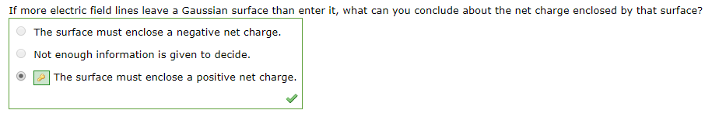

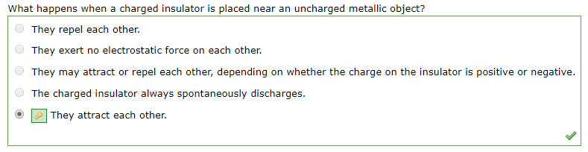

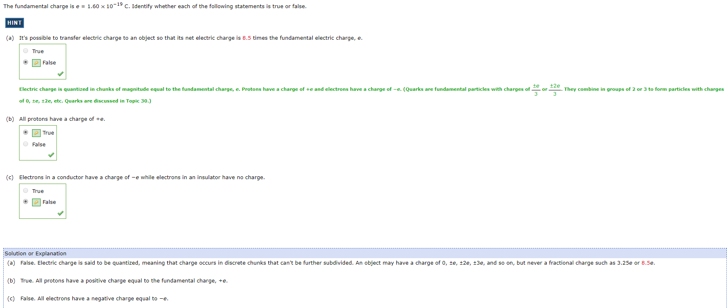

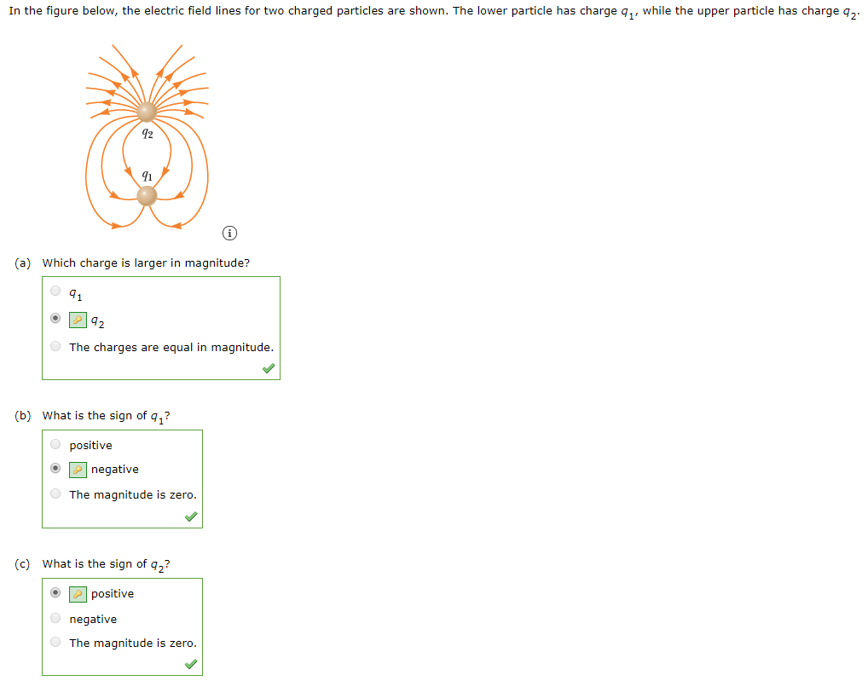

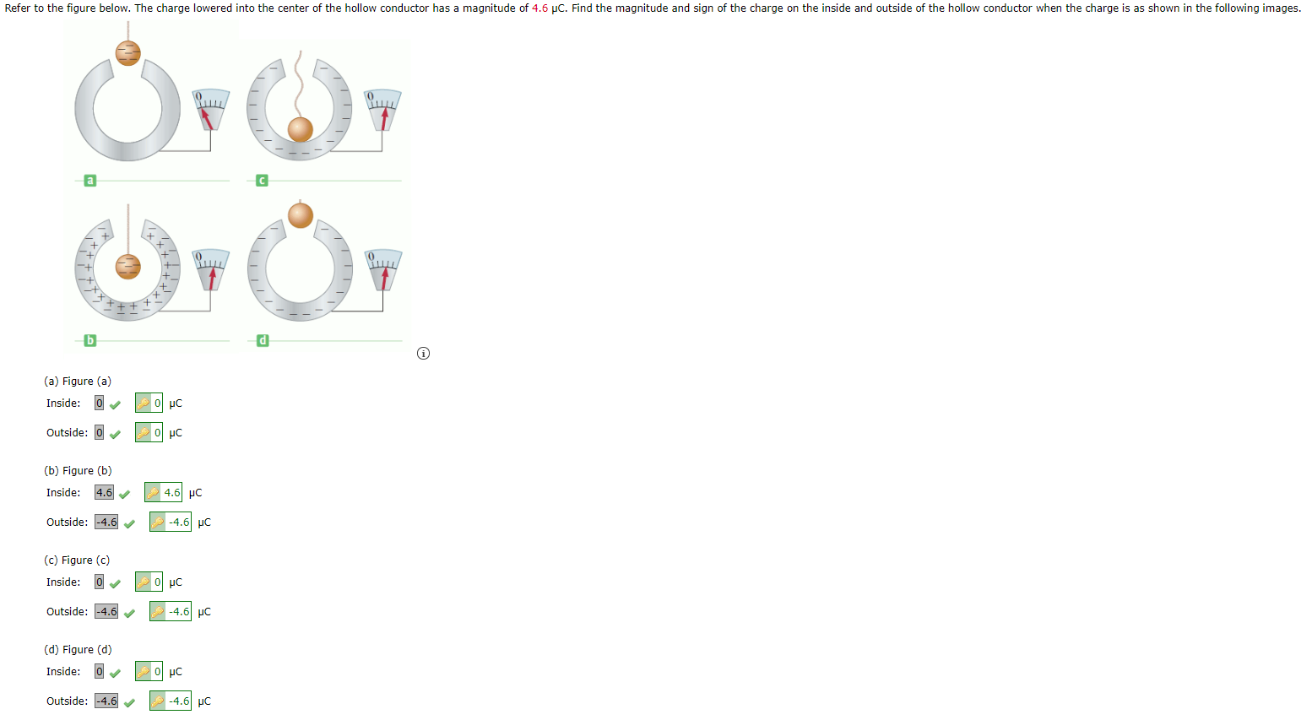

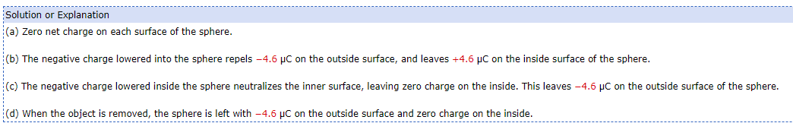

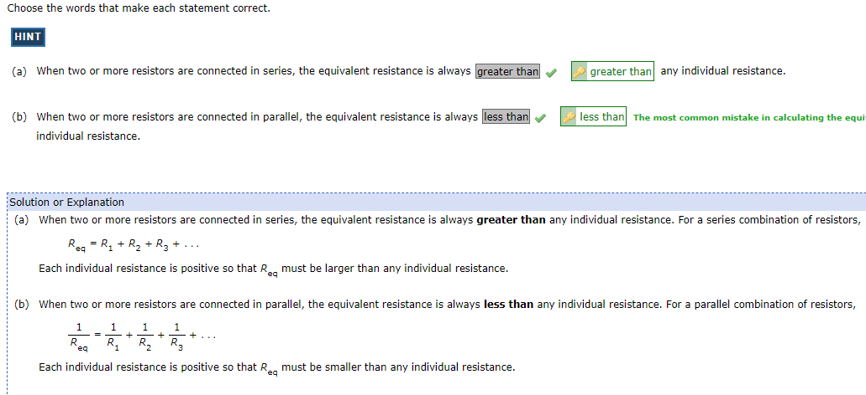

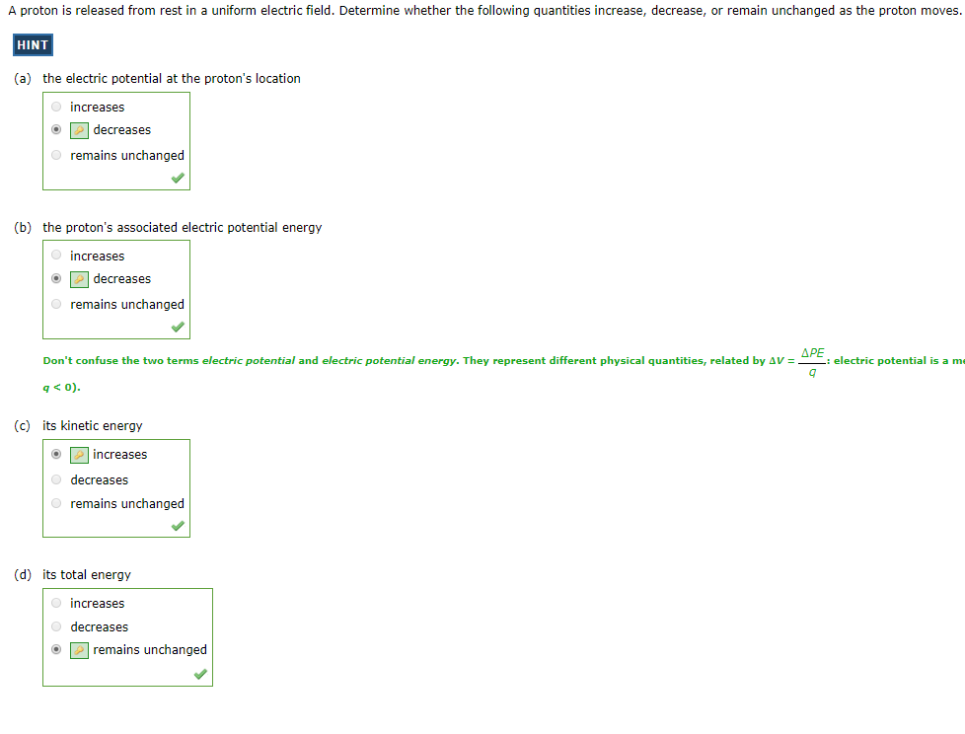

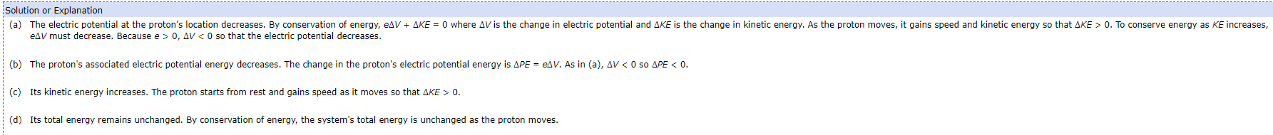

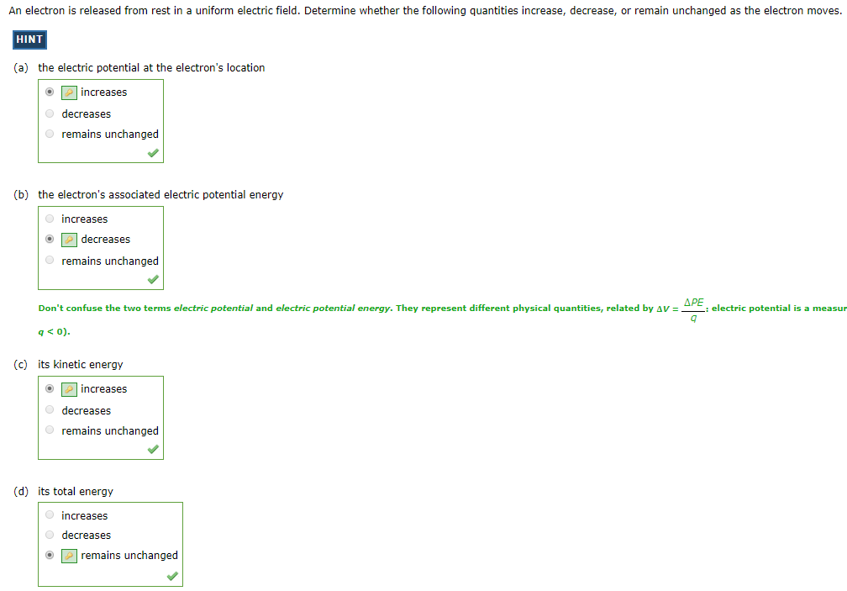

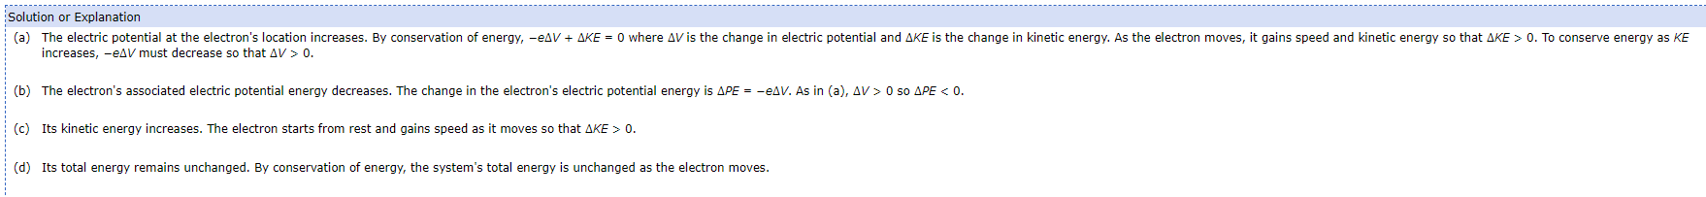

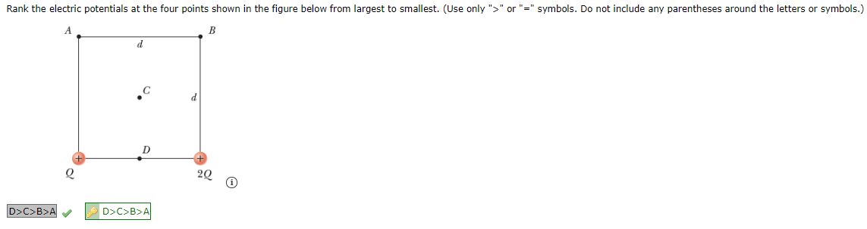

1. A charge will travel through an electric field. You will indicate that you know what happens to the potential energy, kinetic energy, and total energy of the electron as it does so.

* If no NON-Conservative forces do WORK on the system then energy is conserved.

1. Problem 1, 2, or 3 from the assignment “Basic Charge and Coulomb’s Law”

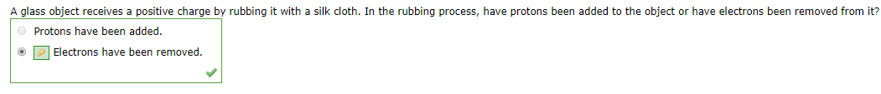

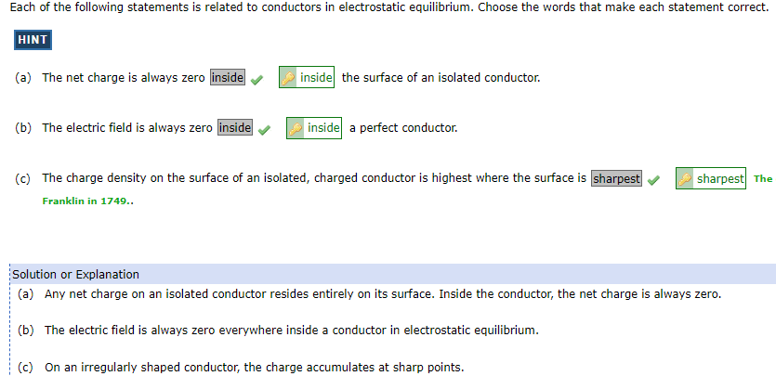

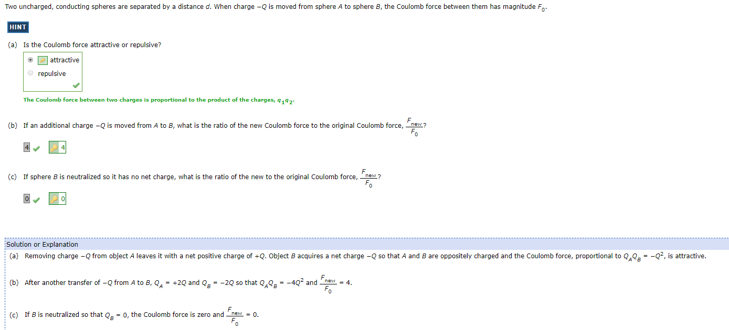

1. I will select one of problems 4, 5, 7, or 8 from the assignment “Basic Charge and Coulomb’s Law”

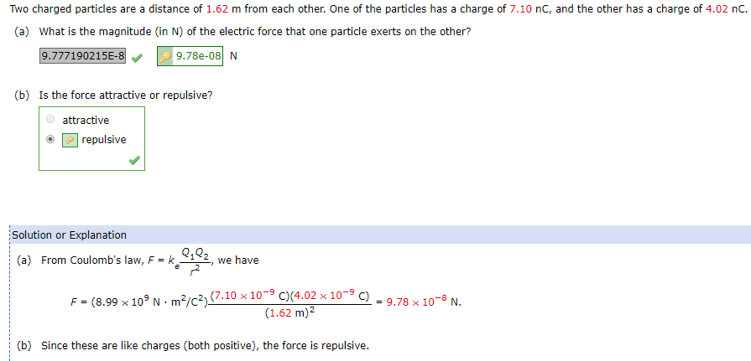

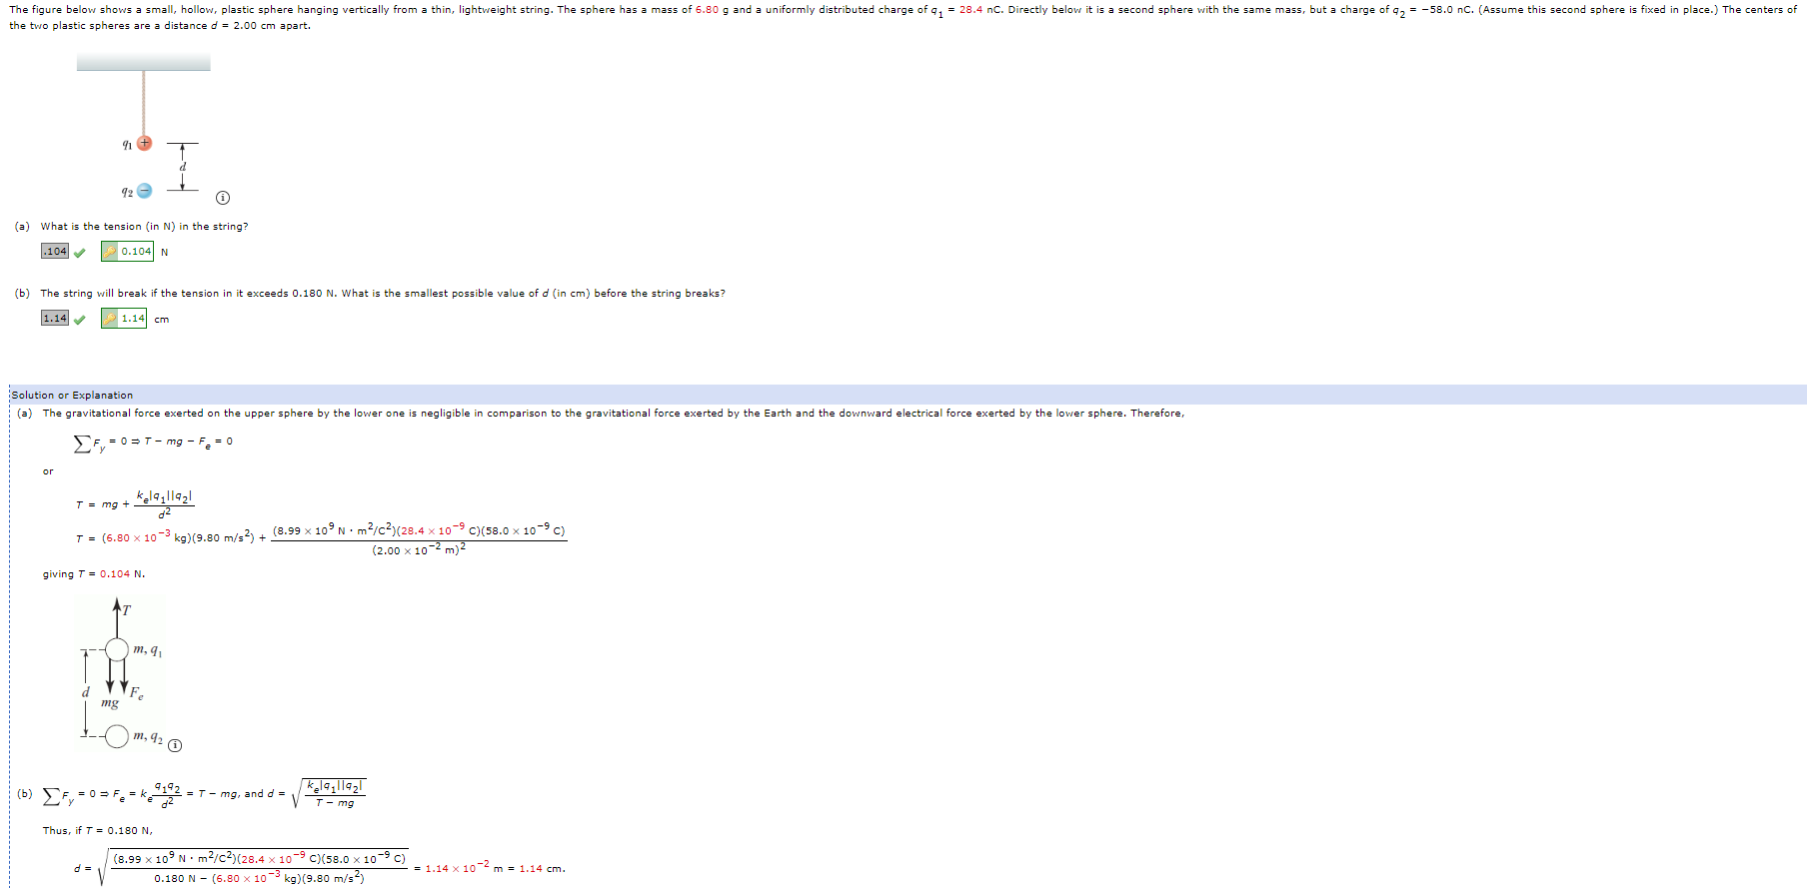

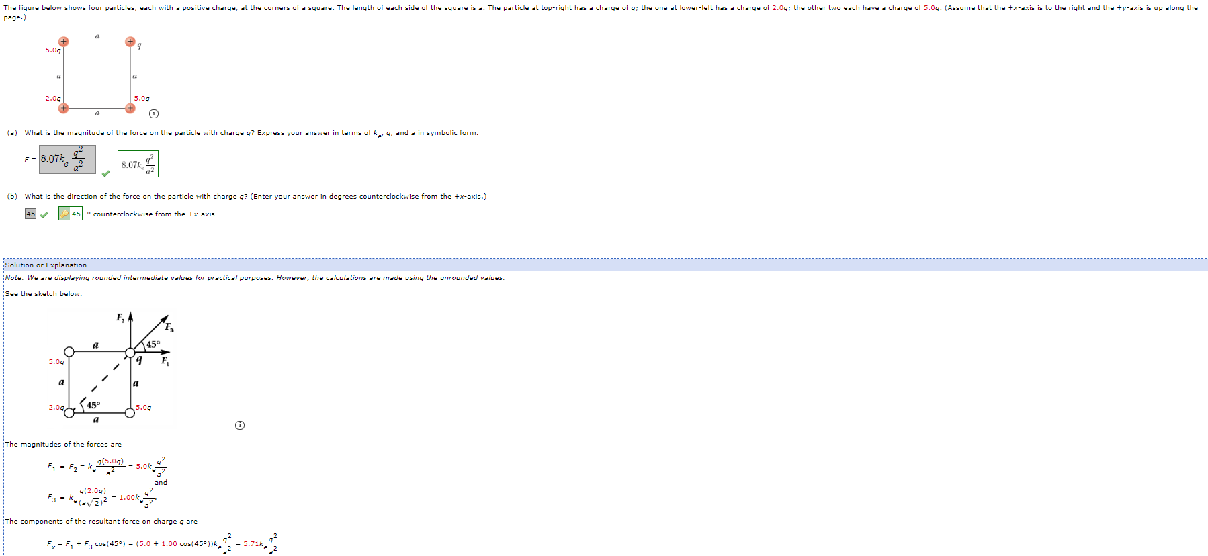

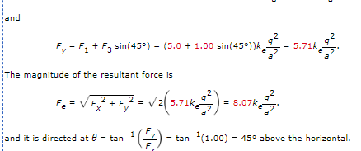

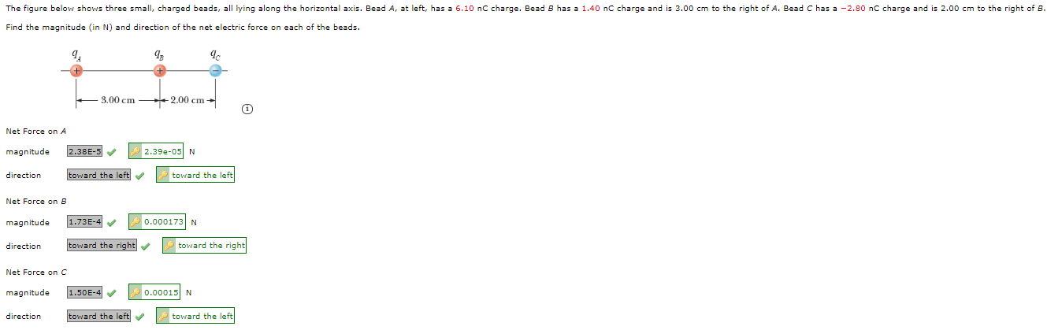

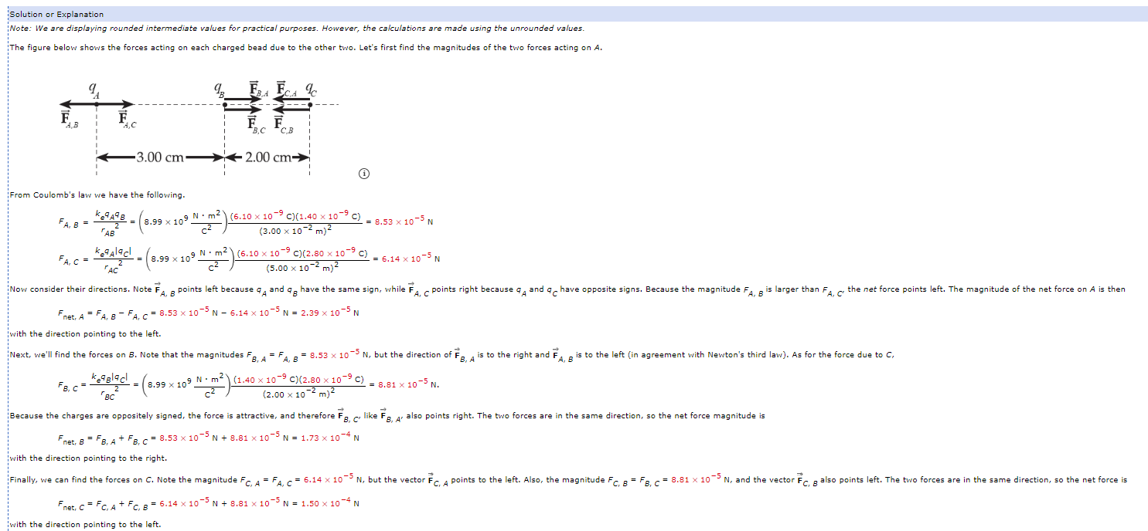

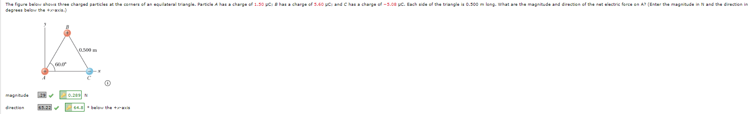

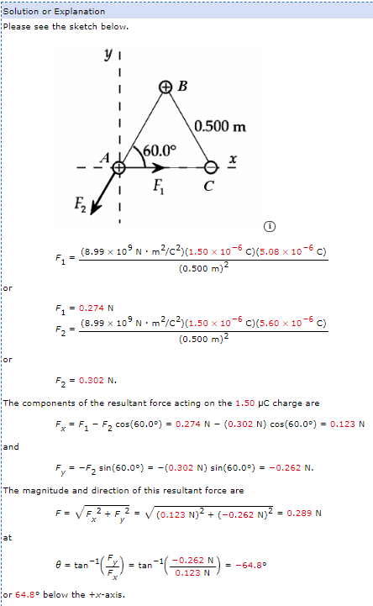

1. One of the problems from the assignment “Potential and Potential Energy”
2. Study problem 1 from the assignment “Resistance and More Potential.” Understand it… don’t just try to remember it.

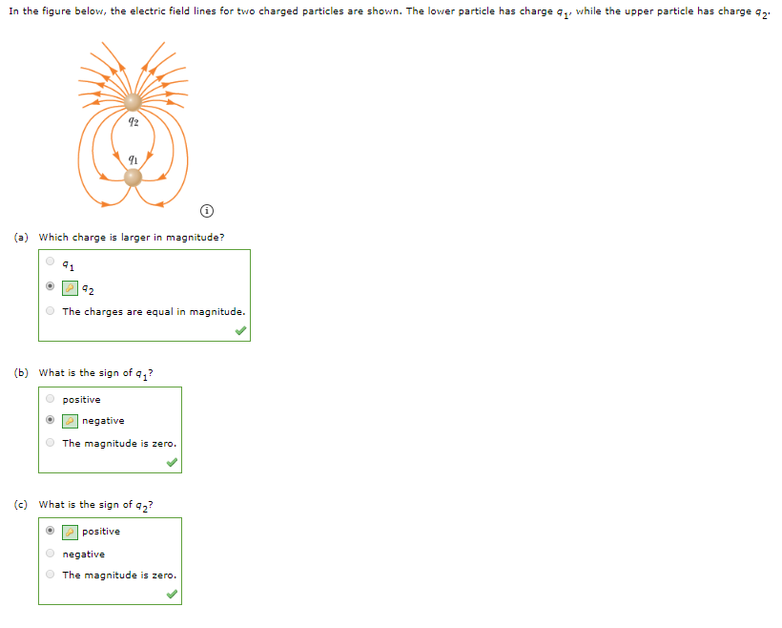



1. I will select one of problems 9 or 10 from the assignment “Kirchhoff’s Rules.”

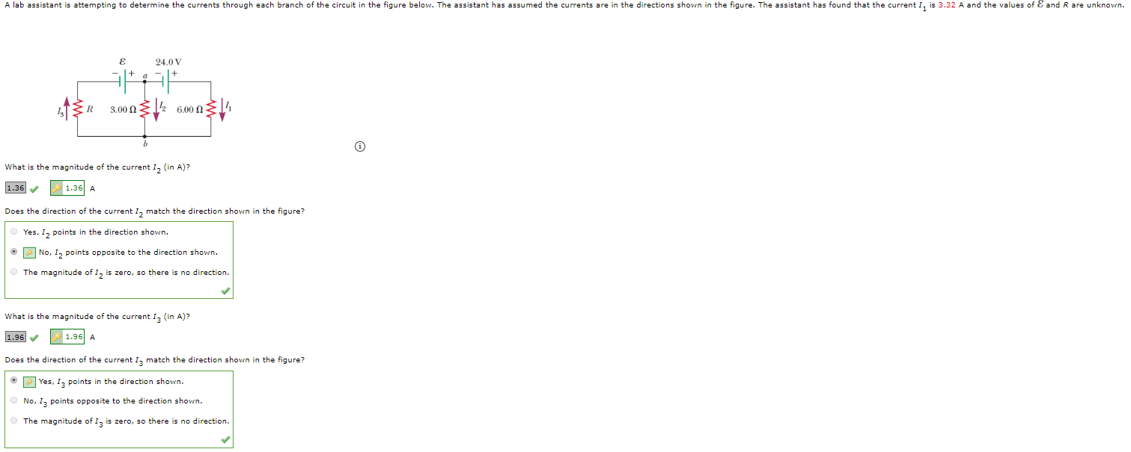

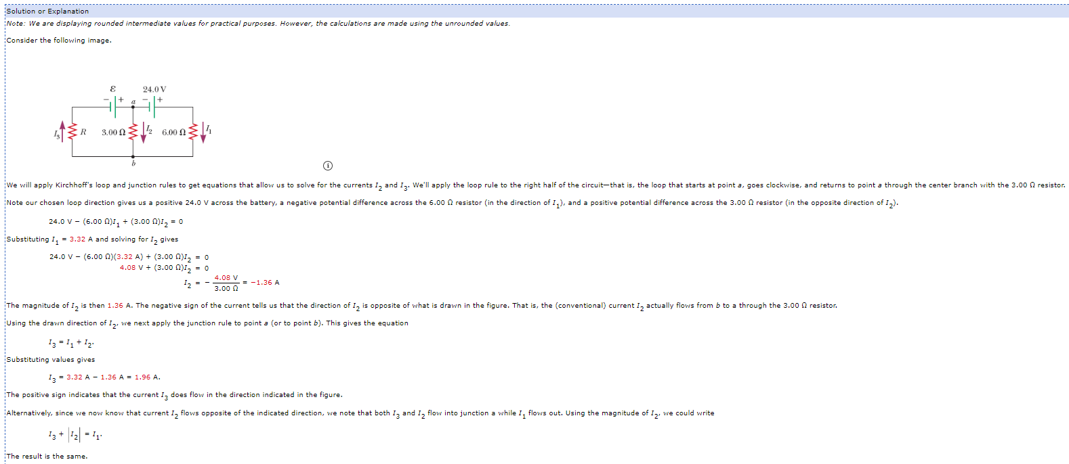

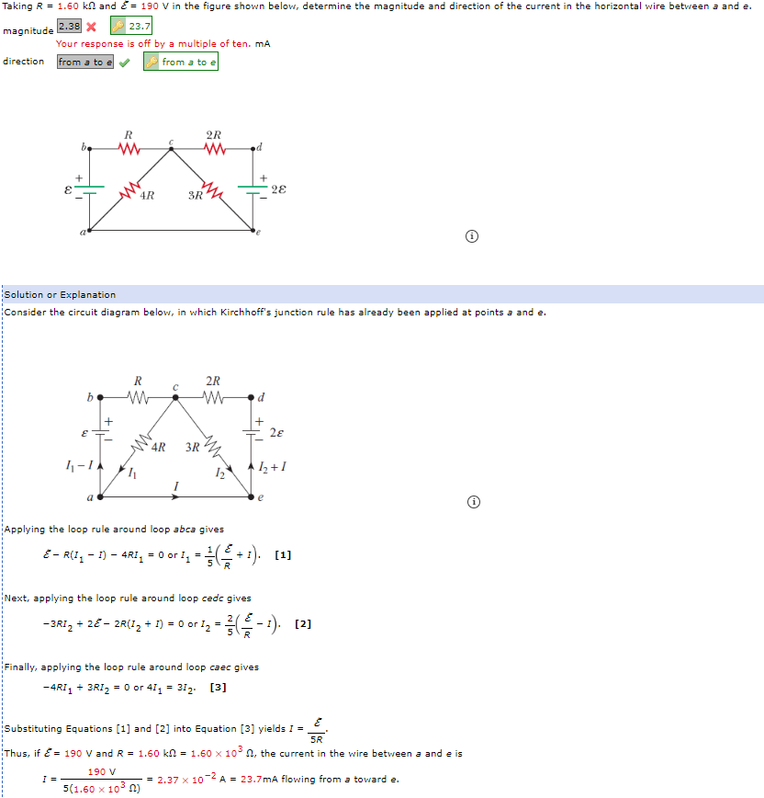

1. Problem 9 or 11 from the assignment “Kirchhoff’s Rules.”

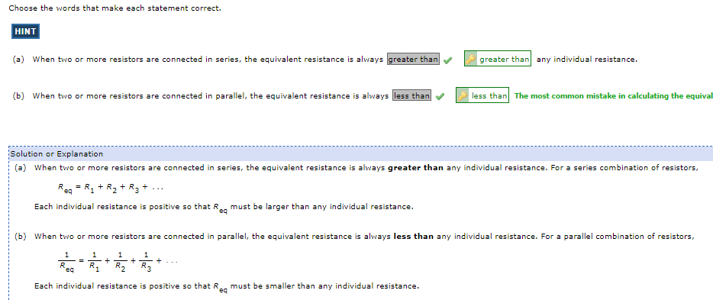

1. Wild card
2. Wild card

#### Computations

1. One of the free response questions from Exam 1.
2. A complex Kirchhoff’s Law problem. Study the problem on the quiz. I will want you to box the equations that you would solve to find the unknown values of the currents. I might ask you some conceptual questions about the circuit as well.